# Technical Design Document: Programming_Exercise_3

# Name: Christian Innes
# Date: October 10th, 2026
# Program Description: Checks to see if information that is entered is valid

##Function:
Calls for the function to start taking in personal information to check if the information entered is valid and if not to return saying it is invalid and to reenter the info
## Parameters:
check_phone – Checks phone
check_ssn - Checks ssn
check_zip – Checks zipcode
##Variables:
Pattern – Uses the pattern to check if it’s entered right
Phone – Stores and Checks the number along with the pattern to see if entered correctly
Ssn – Stores and Checks the SSN and pattern to see if entered correctly
Zipcode – Stores and Checks the Zipcode and pattern to see if entered correctly
##Logic:
Asks for input of phone number
Asks for input of SSN
Asks for input of Zip Code
Checks all information to see if entered correctly and valid
Returns with if it’s valid or not

##Return:
Returns with if the information entered was valid or invalid.

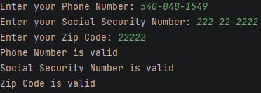

#Link to your repository: https://github.com/monky6676/COP2373

